**Rhythm**

**Runner**

**Project Report**

California State University, Northridge

COMP 467 Multimedia Systems

Fall 2017

**Prepare By Team X:**

Dillon Hour

Hongyou Xiong

Paul Fussell

December 2, 2017

**4.3 Wireframes**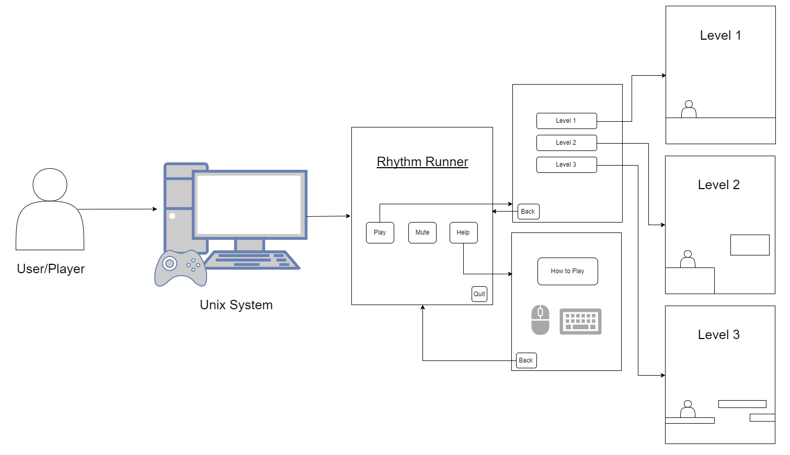

**5. UML Diagrams**

* **Class Diagram -**

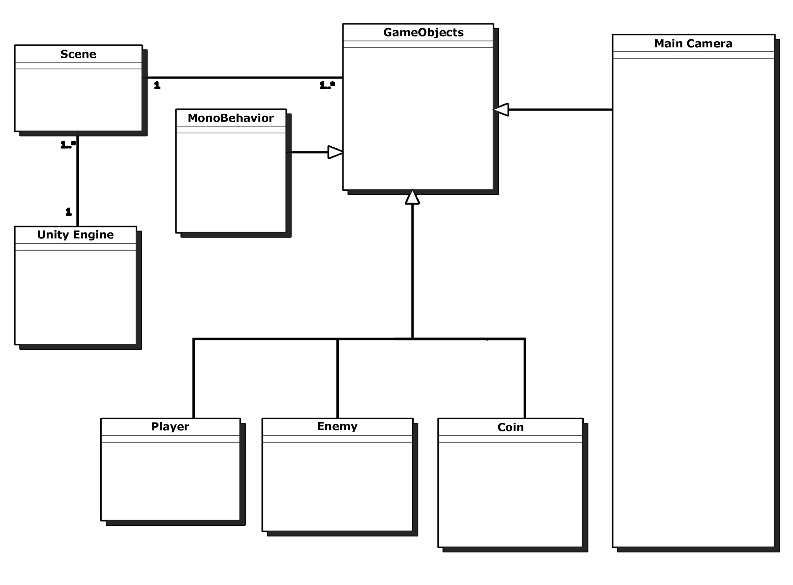

* **Package Diagram** -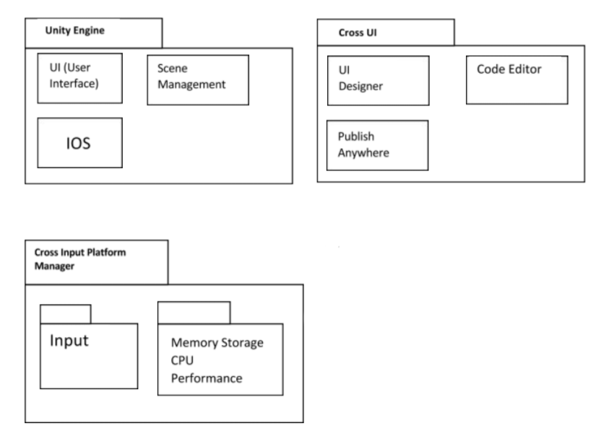
* **Object Diagram -**

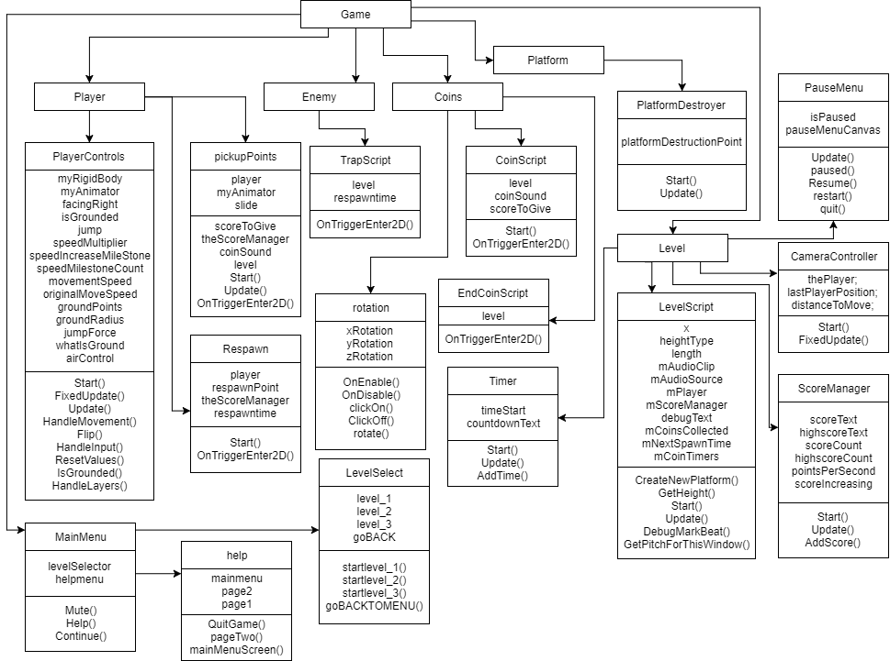

* **Component Diagram -**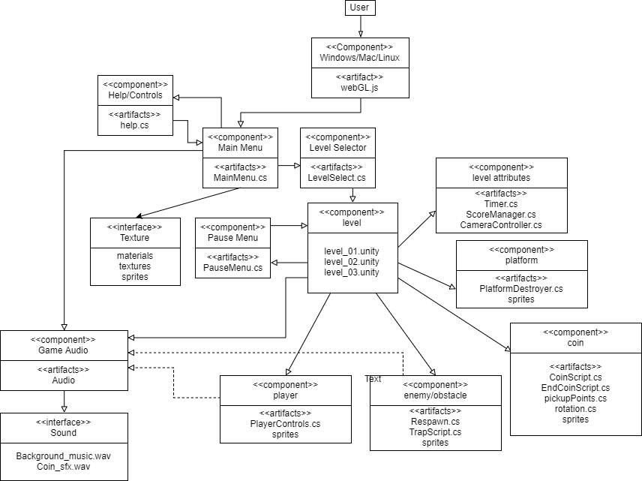

* **Activity Diagram -**

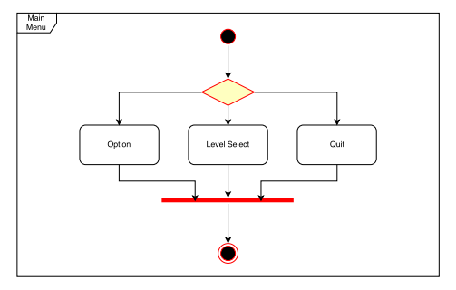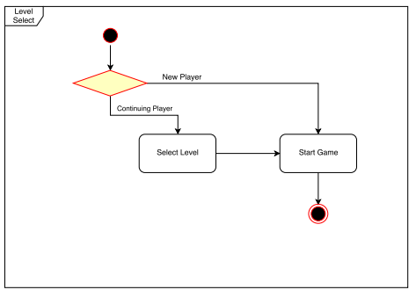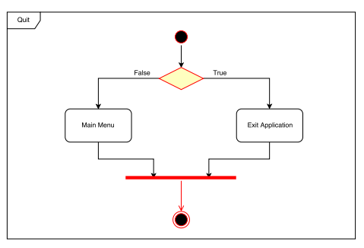

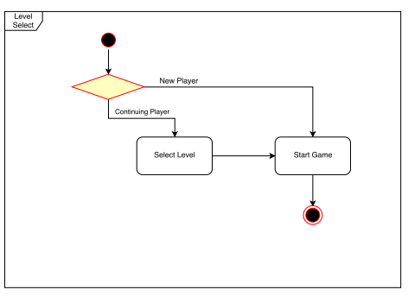

* **Use Case Diagram -**